Yi Peng

AndrewID:yipeng

12-746 2021

Visualization of Bridges in Pittsburgh

2021/9/9

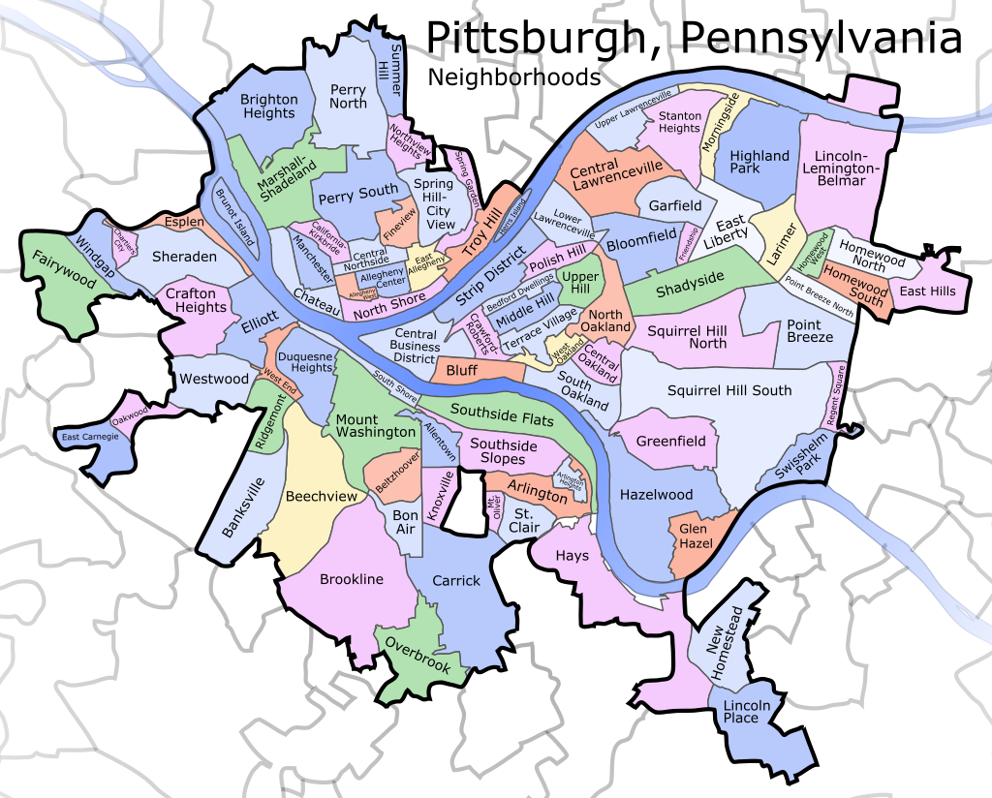

Data source:

https://infobridge.fhwa.dot.gov/Home

https://data.wprdc.org/dataset/pittsburgh-bridges

1. Introduction

Problem Definition

Pittsburgh is also called the “city of bridges”. There are about